**Case Study 2: Drone Delivery**

Student's Name

Institutional Affiliation

Course Number and Name'

Instructor's Name

Due Date

**Case Study 2: Drone Delivery**

**Introduction**

In the modern world, organizations and increasingly becoming inclined to technologize most aspects of daily life, in an attempt to make service delivery efficient and fast. Drone technology is particularly fashionable today, with various industries, including film, agriculture, and the military, and recently, retail businesses actively exploring the idea of drone delivery. The underlying assumption is that this interesting technology can radically enhance the efficiency of service delivery. This innovation is no doubt projected to revolutionize incumbent industries. Small-scale trial services firms have utilized this type of delivery around most of the country, which projects a promising future for drone delivery. Large firms such as Amazon, Walmart, DHL, and UPS have intentionally invested in this initiative, and even though it has not materialized yet, there is hope that this technology will provide a viable solution in the long run.

Notably, most sectors embrace these unmanned aerial vehicles for delivery as they are eco-friendly. In the quest to attain a zero-carbon emission footprint by 2050, most firms have been leaning towards this efficient transportation for future endeavors. Over the last few years, several companies have earned permission from the FAA to indulge in drone delivery. In 2016, Amazon delivered its first package to a customer via the Amazon drone delivery services (Mittendorf et al., 2017). The e-commerce powerhouse has optimally utilized technology, pivotal in its outstanding growth over the years. For a more efficient service delivery system, Amazon launched one of the latest prototypes duped as Amazon Prime, estimated to cover approximately 86 percent of e-business deliveries (Choi & Schonfeld, 2018). Most people are excited about this innovation, but concerns about its safety and sustainability still linger, and these companies are working on addressing the arising issues. In this paper, I will analyze emerging issues and the benefits of drone delivery technology, as well as the impacts on its management operations.

**Issues in Drone Delivery**

Drone delivery has been successfully incorporated in some fields, such as the film and healthcare industries. However, this technology is relatively new and faces a range of challenges, including skepticism from customers. While most people appreciate the timely delivery, its safety and sustainability issues remain an urgent dilemma. In the health sector, unmanned aerial vehicles deliver medication and possibly transport injured patients. Most of the general population are skeptical of providing consumer goods using drones. Most people doubt the efficacy of medical delivery as they doubt its patient-focus capability. Concerns about physical safety, environmental impacts, and privacy considerations derail the full induction of the drone delivery system (Stephan et al., 2022). Stakeholders must ensure they are actively involved in future research and offer potential consumers a clear footprint of this innovation’s practicability.

Most companies share similar objectives and expectations in drone delivery technology. The technology is more versatile, efficient, and cost-saving, and reduces environmental impact compared to traditional delivery methods such as mail trucks. As more industries open up to incorporate drones as delivery tools, studies estimate a possible market value of 127 billion dollars for drone-powered solutions (Mittendorf et al., 2017). Shipping firms, including UPS and Amazon, are working to remotely replace conventional standard delivery and fly products such as medical supplies. In its latest updates, Amazon announced its plans to expand drone delivery services by introducing medication delivery, which will premier in Texas. Similarly, UPS introduced health drone deliveries via CVS Health, which was thriving before its closure (Roush, 2023). These two companies aim to offer customers fast and reliable medication deliveries, which is a viable goal.

Unmanned aerial vehicles (UAV) are the latest innovation in the logistics sector, and it is projected they will lead to tremendous growth in this industry in the coming years. Retail businesses such as Amazon and Walmart have ascertained that drones might be the game changer in service delivery. The technology has more functions than just recreational aspects, and more industries have embraced its high-tech delivery capability. The filmmaking industry has greatly benefitted from this innovation as drones capture scenes beyond human reach more effectively. Real estate relies on quality photography, which is its point of sale, and the UAVs are ideal for capturing aerial views, providing a greater perspective and context to potential buyers (Forstadt, 2021). Consequently, security organizations such as police officers and the EMS utilize drones for their search and rescue (SAR) missions. The technology is ideal in such missions as it can effortlessly access remote areas and has been successfully used during disasters and emergencies.

Consequently, drone technology is projected to skyrocket in the coming years as more corporations embrace UAVs in their business operations. For instance, Walmart plans to expand its drone deliveries to more destinations like Dallas (Roush, 2023). Such forecasts guarantee a bright future for unmanned aerial vehicles. The modern world is fueled by technology, which makes venturing drones much easier. During the COVID-19 pandemic, contactless deliveries gained popularity, and the general public has embraced this idea entirely. With such a promising base, drone delivery will likely succeed in the contemporary world as anticipated after addressing emerging issues such as safety and confidentiality. Major corporations such as Amazon foresee a possible overtake of freight technology in the viable future. Indisputably, a gap in service delivery exists that drone delivery will alleviate seamlessly.

In its considerable efforts to expand its drone delivery services, Walmart has launched several drone services in the Tampa Bay area. As seen in Figure 1 below, the retailer is rolling out this service through the Drone-Up Tech company, and customers can now have their groceries delivered by a drone.

**Figure 1**

***Drone Delivery Location***

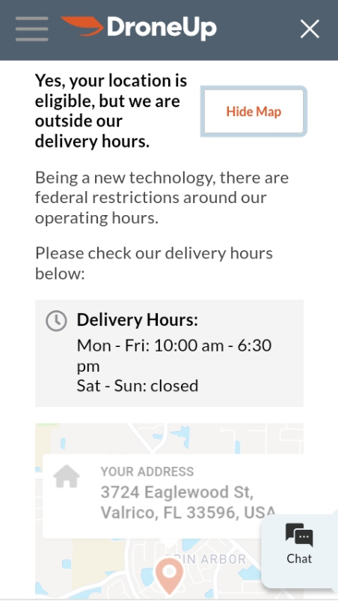

**Survey**

Table 1 below shows the results of an ad hoc survey of drones from Amazon or Walmart.

|  |  |  |  |  |  |  |
| --- | --- | --- | --- | --- | --- | --- |
| **Table 1. Survey Results – Ad hoc Interviews Drones** | | | | | |  |
| **Number** | **First Name** | **Age** | **Profession** | **Do they know there are drone deliveries in the Tampa area?** | **Have they seen a drone delivery?** | **Rank their opinion on drones for delivery from Very positive, Somewhat positive, Neutral, Somewhat negative, Very negative, Not sure.** |
| 1 | Mary | 45 | Accountant | yes | No | Neutral |
| 2 | Isaac | 30 | Software Engineer | yes | Yes | Very Positive |
| 3 | Hazel | 22 | Digital Content Creator | Yes | Yes | Somewhat positive |
| 4 | Daniel | 60 | Tour Guide | No | No | Not Sure |
| 5 | Linda | 38 | Realtor | Yes | Yes | Neutral |

Different individuals have distinct perspectives on drone delivery. Young people, especially Gen Zers aged between 20 and 25, are more conversant with this technology and are likely to embrace drone delivery compared to other demographic groups. These individuals are digital natives; most have interacted with a drone at least once. Contrarily, the older generation portrays skepticism toward this type of technology as they question its sustainability and safety. Most people in this group aged 50 years and above have not had a direct with a drone or a drone delivery, which explains their neutral perspective about the technology. Amusingly, middle-aged people are also open to drone delivery services as they believe it will ease their purchasing and busy lives. Most interviewees who had doubts about this innovation had little to no knowledge, which significantly contributed to their unsure perspective. With proper awareness, more people are inclined to embrace drone delivery services as they are fast and cost-effective.

**Conclusion**

Notably, drone delivery is a new technology, and most people are skeptical of its credibility. The technology has performed well previously in industries such as filmmaking, increasing its chance of overtaking the logistics sector. Most people are concerned about its safety and confidentiality for consumer goods delivery, which are genuine concerns, and stakeholders have to ensure that the general public has more insight into this technology before launching. As corporations like Amazon and Walmart introduce this service to their customers, more people have become more receptive to this innovation. Different demographic groups have distinct perspectives on the drone delivery service, and more young people are embracing the technology better compared to their counterparts in the senior citizens’ category. Drones have revolutionized most sectors, such as the photography and search and safety departments, proving that it is eligible to transform the freight industry. Stakeholders must ensure that the general public gets proper awareness of this technology, which will be pivotal in a positive reception.

**References**

Choi, Y., & Schonfeld, P. M. (2018). Drone Deliveries Optimization with Battery Energy Constraints. In *Proceedings of the Transportation Research Board 97th Annual Meeting, Washington, DC, USA* (pp. 7-11).

Forstadt, A. (2021, July 8). *Ten drone-powered business ideas*. https://www.uschamber.com/co/. https://www.uschamber.com/co/start/business-ideas/drone-powered-business-ideas

Mittendorf, C., Franzmann, D., & Ostermann, U. (2017). Why would customers engage in drone deliveries? In *AMCIS*.

Roush, T. (2023, October 18). *Amazon will start delivering prescriptions by drone*. Forbes. https://www.forbes.com/sites/tylerroush/2023/10/18/amazon-will-start-delivering-prescriptions-by-drone/

Stephan, F., Reinsperger, N., Grünthal, M., Paulicke, D., & Jahn, P. (2022). Human drone interaction in delivery of medical supplies: A scoping review of experimental studies. *PloS One*, *17*(4), e0267664. https://doi.org/10.1371/journal.pone.0267664