Windows Network Proposal – Networking

Name

Institution

Windows Network Proposal - Networking

Working for Fixing Windows LLC is such a great opportunity for not only developing an effective technology solution that best suits the needs of the organization but also familiarizing with excellent prospects of the industry. In this paper, the server and deployment version will be discussed into details as well as their roles. Also, the proposal will elucidate aspects surrounding DNS, DHCP, Active Directory, application services, and file sharing printer. Further, the paper will shed light on backup system concerns and fault tolerance which is highly attributable to the system failure. Lastly, the report will recommend the appropriate devices to assist in the prevention of any uncertainties in the long run.

**Deployment and Server Editions**

The worldwide advertising incorporation’s network infrastructure has to significantly significant on the features and roles of the server. The organization will have to major in highly-virtualized private cloud environment since its offices are separate geographically in Dallas, Los Angeles, and Houston. Clients should have devices with at least Windows 8 to match the Windows 2016 Datacenter (Snover, 2012). Using the operating system will provide the organization’s administrator four terabytes of RAM for client access licenses, unlimited virtual instances, and processor and every server. Also, Windows Server 2016 will offer LAN connections and universal remote, RRAS connections together with the Hyper V guest’s operation system.

The organization will have seven servers in Dallas and three in Houston, which is the headquarter. The server core will be operational in Los Angeles since it is not a significant office, and the IT activities are limited (Microsoft Hyper-V Server 2012, 2015). Also, the windows deployment services will be useful in installing operation system in the computers. The process is expected to be time-consuming, but less time will be taken while running the program on each computer. After the installation, the servers will be arranged in a preset way to avoid errors. Table 1 below shows the features and roles each server will play.

Table 1. Servers’ Features and Functions

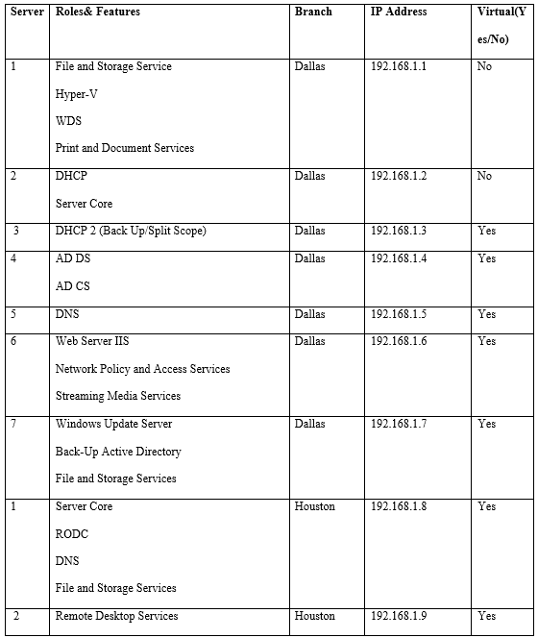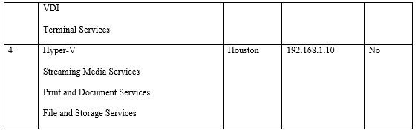

**Active Directory**

Every branch should have its active directory. The recommended parent company active list is worldwide.local while the domains are dallas.worldwide.local, la.worldwide.local, houston.worldwide.local for the three cities respectively. With these domains, the Los Angel domain will be a read-only since the IT activities are limited.

Further, the use of the domain, the security, rate of log INS, and accessing the network will make the deployment far more straightforward and efficient. The domain at Dallas and Houston office will act as a location of a significant high physical security since the people allowed to the server will only be the IT personnel. Also, external security devices such as CCTV camera will be placed to monitor people trespassing or people within the premise all the time (Windows Server 2003: Deployment Whitepapers, 2011).

Consequently, the read-only domain controller will need no stiff security, and that is why being a read-only since no alteration can be made unless the changes come from the host. Since an organization follows a specific hierarchy, all the department managers will have access to the domain user as they can gain a right of entry to the server and access files that are very important to them.

**DHCP and DNS**

The DHCP will be implemented based on the world advertising incorporation’s IP address that will range from 192.168.1.1-192.168.1.254. The application is on the fault tolerance of 80/20 split that has a substantial lease on the assumption that the user and the environment will remain stable given that it is highly likely to have frequent movements of people and the number of leases will not have changed significantly. The split will take place on the IP address 192.168.1.1-192.168.1.203 and 192.168.1.204 to 192.168.1.254 which is not part of the DCHP server. Further, the back of the DHCP server will split the backup through the IP address from 192.168.1.204 to 192.168.1.254 excluding 192.168.1.1-192.168.1.203. Table 2 below shows the reservation of the ten servers with their IP addresses and the organization’s improvement.

Table 2. IP Address Allocations

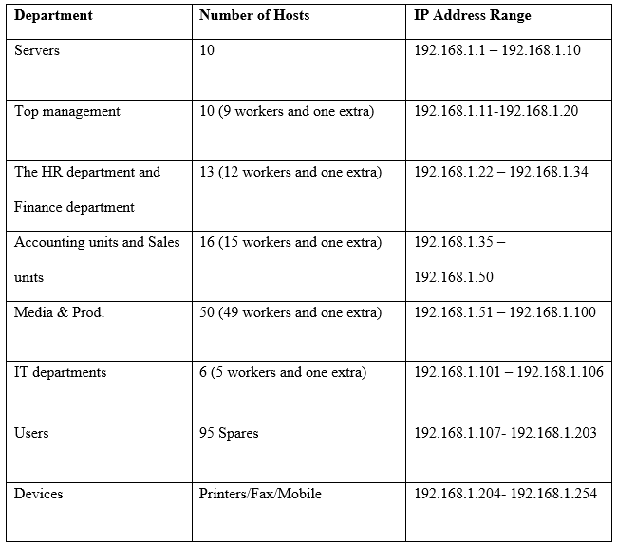

Fixing Windows will have two DNS servers usable by the employees and the public. The domain subject for the organization’s intranet is worldwide.local, and the general public will use worldwideai.org. All DNS servers have unique domain names for offices located in Dallas, Houston, and Los Angeles to avoid confusion. Each domain’s prefix will have the location name followed by the parent name. For example, the Dallas domain will be Dallas. worldwide.local. Since the office in Los Angeles is not among the main offices, the DNS at the office will be installed and handled with RODC so that customers in Los Angeles can carry out DNS lookups during the unavailability of WAN (Microsoft – DHCP Server, 2011).

**File and Printer Sharing**

Sharing files will require the permission of the NTFS, which needs to be configured for the folders and the data on the drive. A sub-folder for the user in every organization unit exists within each folder within a computer. Also, every private user will have another folder which will be encrypted with EFS. Generally, the permission set on the parent folder will help in avoiding any confusion for the organizational units and offer the employees executive permissions.

The Distributed File services will be put into practice, and its replication will be used as the namespace, which will major on copy-pasting folders found in various sites and servers of the three offices. Also, the organization needs to back up the folders always to ensure that the files are secure and cannot be stolen or even get damaged. The use of the namespace will facilitate the sharing of the organization’s administrator folders and files located in the three servers to a different group or into a rational namespace.

Subsequently, the implementation of the File Service Resource Manager will help the organization’s management and the Information Technology (IT) department to recognize and track the space used as well as track any available. Since the LLC organization has a significant market share, each customer will be entitled to one gigabyte, but terms and conditions may apply (Managing Printing Traffic, 2009). Such terms will include a warning when they use at least seventy-five percent of the space, where the rest will act as an allocated space for the organization. Issuing the signal to the customers will sensitize them on their data storage usage and also help the organization to offer them significant services accordingly.

**Remote Services and Network Policy Server (NPS)**

The suggestible technology that the organization should adopt when implementing remote access is SSL VPNs. The technology solution offers VPN the right of entry to any normal browser as no software installation is needed. Also, since the firm wants to upgrade, the SSL VPNs gateway must be placed behind the application layer of the OSI Model of the protocol which gives permission or denies right of entry to a particular application.

Additionally, Fixing Windows should consider the employee’s mail on a server as the personnel, which is exchangeable. Also, it is advisable to issue the remote access to the subset URL’s which is hosted by the intranet web server. The consideration of the two plans is the best for the organization if they do not want to put the organization at risks.

**High-Performance Network Solutions**

High-Performance Network (HPN) acts as a restricted provider panel which offers the member or the customers the right of entry to the well-organized providers within their area of operation. Fixing Windows’ management should adopt this type of network solution to offer goods and services to customers who need solar panels at various locations. With a typical service provider, the cost is drastically reduced because all the customers are located in the same place.

**Software-Defined Networking (SDN)**

Software-Defined Networking SDN entails a network design whose aim is making a flexible and agile network. The fundamental objective of SDN is enhancing the network control through the enablement of service providers and enterprises in responding quickly to business queries. In this scenario, the organization can use the application to enhance a good customer relationship. The network solution will help in determining the specific places with issues instead of skimming around a particular area looking for a problem.

**Conclusion**

Through the configuration and implementation techniques of the window server 2016 datacenter, the responsibilities of the servers DNS server and DHCP server implementation, file and printer sharing, application services and active directory are sufficiently achieved. The implementation of the transition of the network will enable the organization to advance its IT and have considerably more efficient and effective productivity. Also, backing up information and fault tolerance will go a long way to solving the system failure issues.

References

Managing Printing Traffic. (2009). *Creating a printing pool: Network Printing; Print Services*. *Docs.microsoft.com*. Retrieved 26 September 2019, from https://docs.microsoft.com/en-us/previous-versions/windows/it-pro/windows-server-2003/cc757086(v=ws.10)?redirectedfrom=MSDN#creating-a-printing-pool-1

Microsoft – DHCP Server. (2011). *DHCP Step-by-Step Guide: Demonstrate DHCP Split Scope with Delay on a Secondary Server in a Test Lab*. *Docs.microsoft.com*. Retrieved 26 September 2019, from https://docs.microsoft.com/en-us/previous-versions/windows/it-pro/windows-server-2008-R2-and-2008/ee405264(v=ws.10)?redirectedfrom=MSDN

Microsoft Hyper-V Server 2012. ,. . (2015). *Install Hyper-V Server*. *Docs.microsoft.com*. Retrieved 26 September 2019, from https://docs.microsoft.com/en-us/previous-versions/windows/it-pro/microsoft-hyper-v-server-2012-R2-and-hyper-v-server-2012/jj647783(v=ws.11)?redirectedfrom=MSDN

Snover, J. (2012). *Windows Server 2012 Remote Desktop Services (RDS) - Windows Server Blog*. *Windows Server Blog*. Retrieved 26 September 2019, from https://cloudblogs.microsoft.com/windowsserver/2012/05/08/windows-server-2012-remote-desktop-services-rds/

Windows Server 2003: Deployment Whitepapers. (2011). *Best Practice Guide for Securing Active Directory Installations*. *Docs.microsoft.com*. Retrieved 26 September 2019, from https://docs.microsoft.com/en-us/previous-versions/windows/it-pro/windows-server-2003/cc773365(v=ws.10)?redirectedfrom=MSDN